***WEDDING CAKE CONTRACT***

Order Date:

Total Price of Cake:

|  |  |
| --- | --- |
| **Initial Deposit** | **Final Payment** |
|  |  |

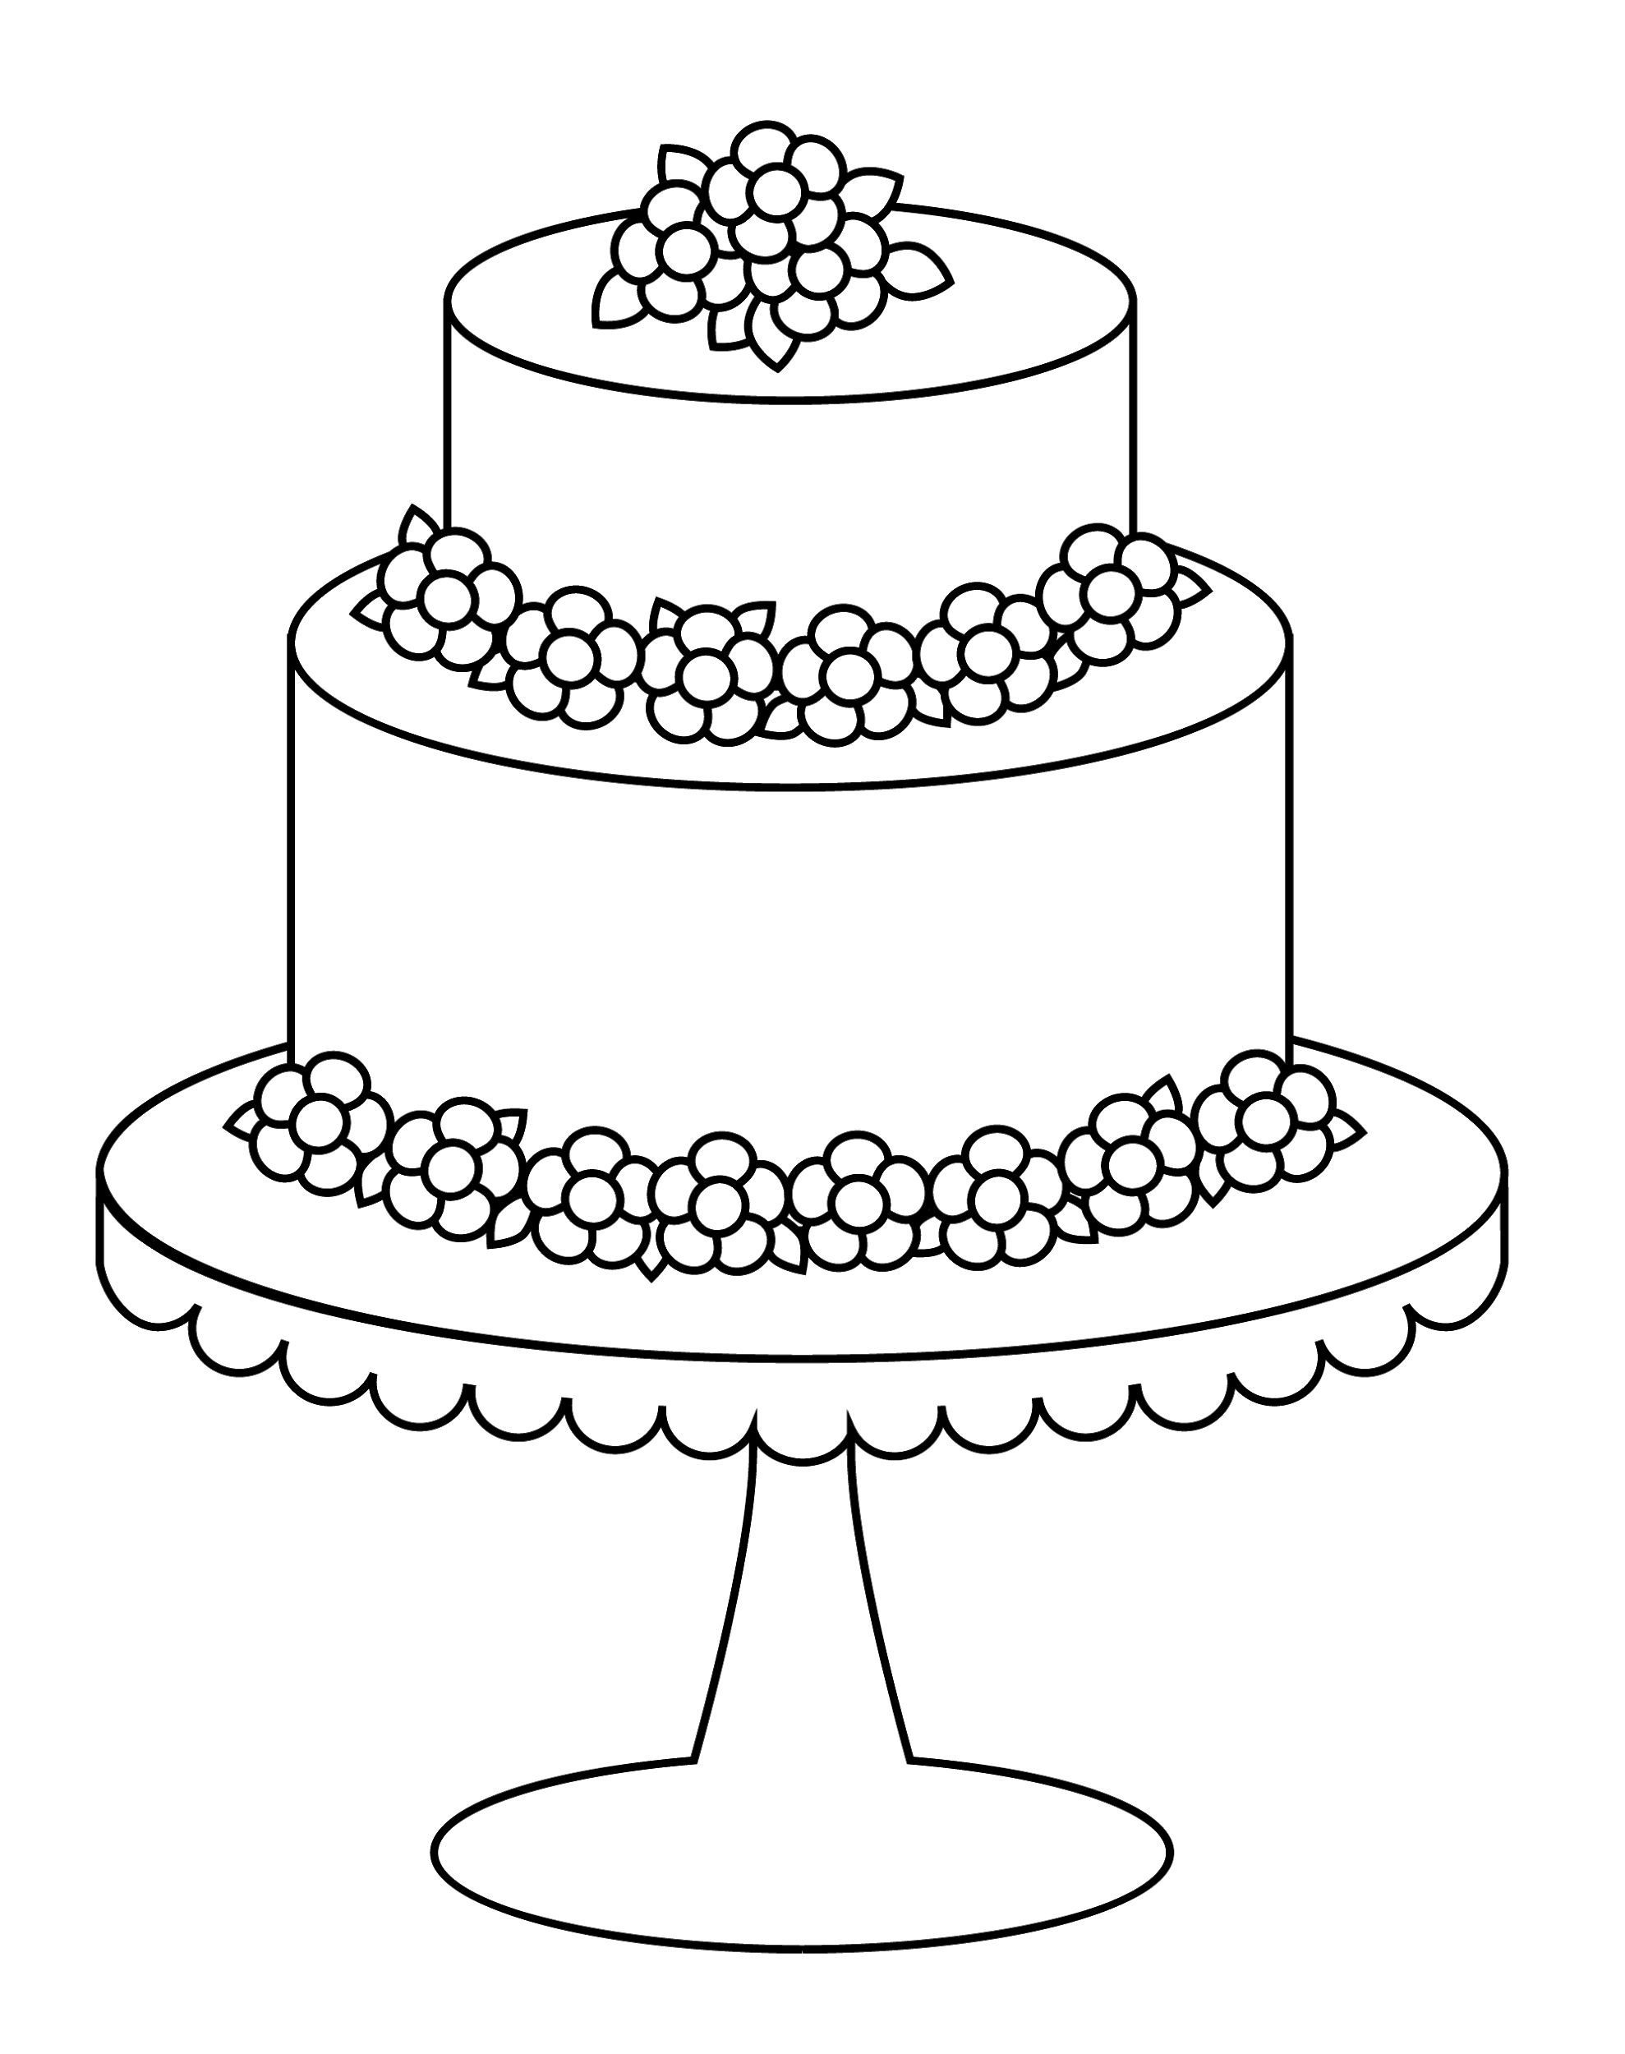

***EVENT DETAILS***



Wedding Date and time:

Venue (including room specifics):

Venue Contact:

Number of Guests:

|  |  |  |
| --- | --- | --- |
| **Client Name** | **Client Email** | **Client Phone** |
|  |  |  |
|  |  |  |

|  |  |  |
| --- | --- | --- |
| **Emergency Name** | **Emergency Email** | **Emergency Phone** |
|  |  |  |
|  |  |  |

***ORDER SPECIFICS***



Number of Servings:

Extra Information:

|  |  |
| --- | --- |
| **Tiers, Flavors, and Fillings** | |
|  |  |
| **Tier 1** | **Tier 2** |
| **Tier 3** | **Tier 4** |

|  |
| --- |
| **Flowers** |
|  |

|  |
| --- |
| **Design (Photos & Sketches)** |
|  |

***PRICING AND PAYMENT***



**Itemized Cost**

***Retainers, Deposits, Payments & Taxes***

1. The date of the event is considered “booked” upon receipt of a non-refundable deposit equaling % of the total value of the cake, delivery charges, equipment deposit and signed contract.
2. The final payment is due days prior to the event.
3. If the cake is booked days or less before the reception, the deposit will equal % of the total cost,
4. If the Client fails to make payments, **[YOUR BAKERY NAME]** will cease work, the order will be cancelled and no refund will be given.
5. Preferred methods of payment are .
6. The Client will have a grace period of days after the payment date to pay debt before the contract is canceled.
7. Late payments will be charged a fee.
8. Returned checks and surcharges will be charged a fee.

***Terms and Conditions***

1. **[YOUR BAKERY NAME]** is not responsible for bodily injury, property or consequential damage, which may result from services.
2. **[YOUR BAKERY NAME]** is not responsible for any damage to the cake or shortage of cake caused by anyone NOT employed by **[YOUR BAKERY NAME]**.
3. **[YOUR BAKERY NAME]** will not deliver a cake if payments have not been paid in full.

***Fulfillment of Contract***

1. **[YOUR BAKERY NAME]** is not responsible for any delay or inability to deliver based on accidents, natural disasters, transportation issues, inclement weather, illness, death, labor troubles, delay in supplies, disputes or strikes, or any other circumstance beyond **[YOUR BAKERY NAME]’**s control.
2. If **[YOUR BAKERY NAME]** has completed the cake but it can’t be delivered due to uncontrollable circumstances, the Client will be refunded % of the total cost.
3. If Client picks up the cake, **[YOUR BAKERY NAME]** no longer assumes any responsibility for damage caused to it.

***Postponement/Cancellation***

1. The Client must notify **[YOUR BAKERY NAME]** if there is a change in the date of the event or a complete cancellation.
2. If the postponement occurs before days of the event, no penalty fee will be charged.
3. If the postponement occurs after days prior to the event, the Client will be charged a fee.
4. If a cancellation occurs days prior to the date of the event, all money will be refunded minus the retainer fee.
5. If a cancellation occurs after days prior to the event, % will be refunded less the non-refundable retainer fee.

***Changes to Order***

1. Any changes must be submitted days in advance.
2. There will be no changes allowed days prior to the event.

***Design of the Cake***

1. **[YOUR BAKERY NAME]** will follow the Client’s requests closely to create the exact cake desired.
2. **[YOUR BAKERY NAME]** cannot duplicate an exact copy of another cake artist’s work but will ensure the look is similar.

***Serving Amount & Sizes***

1. The serving size is inches wide inches long inches high.
2. Serving size estimations are not guaranteed to be exact.
3. **[YOUR BAKERY NAME]** is not responsible for a shortage of cake if the pieces are cut too large.

***Allergy & Dietary Warnings***

1. **[YOUR BAKERY NAME]**’s baked goods may have come in contact with the following ingredients:

* _____________
* _____________
* _____________
* _____________
* _____________

1. Natural dyes, artificial dyes, artificial flavorings, sugar, artificial sweeteners, artificial color and other allergens not listed.
2. The Client is responsible for pointing out to guests potential allergy hazards.

***Ornaments & Special Equipment***

1. A deposit is required for all rental equipment.
2. The equipment must be returned within hours of the event.
3. The returned equipment is evaluated and a refund of the deposit is based on the condition of the items.
4. All personally supplied items must be submitted to **[YOUR BAKERY NAME]** at least days prior to the event

***Delivery and Set-Up***

1. There is a delivery fee of .
2. **[YOUR BAKERY NAME]** is not responsible for tardiness if the venue is changed within 48 hours of the event.
3. The Client may pick up the cake. The Client assumes liability once it passes into the Client’s possession.
4. The Client is responsible for providing a suitable environment for the cake (away from heaters, vibrations, people, suitable surface, suitable outdoor setting).
5. The Client must sign a waiver to ensure the condition of the cake is satisfactory.
6. Once the waiver is signed, **[YOUR BAKERY NAME]** is not responsible for cake including collapse, melting, pokes etc.

***Photographs***

1. **[YOUR BAKERY NAME]** reserves the right to use all photographs of the cake for advertising purposes.

**WEDDING CAKE CONTRACT AGREEMENT**

Please sign below to indicate that you agree to the above details of your order as stated in this contract.

|  |  |
| --- | --- |
| **Signature** | **Date** |
|  |  |

